TI 22-28. Technology Example – WellHop
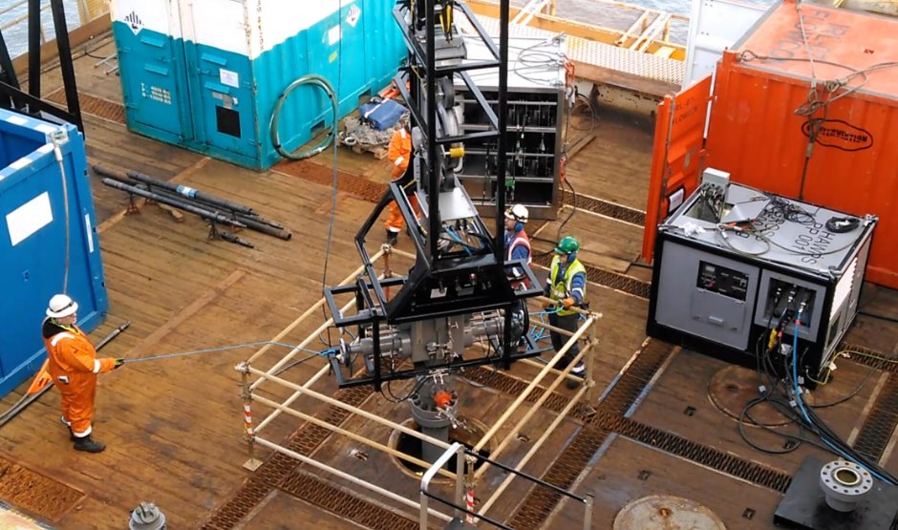
Description of the technology:​

Wellvene’s WellHOP™ is a Shallow Application Slickline System that reduces operational risk, time, cost and personnel, whilst simplifying the overall pressure control equipment rig up, for operationally-efficient repairs. ​
​
After completing onshore trials in Q4 last year, the WellHOP™ Shallow Application Slickline System is already bringing significant time and cost benefits to North Sea Well Integrity and DHSV Remedial Operations. This includes Wellvene’s recent work with a major North Sea Operator where the WellHOP™ was used to drift the wellbore to TRSSSV depth and set an Interwell bridge plug and junk catcher on two wells as part of a temporary suspension workscope.​

Eliminating the need for a mast and separate wireline winch, the WellHOP™ can be rigged up onto the well in two lifts and moved between further wells in a single lift. Its operation eliminates the rig down, repositioning and rig up required with more traditional slickline methods

Currently only suitable for near surface work (3000ft) but looking to develop for deeper work (18,000ft)

When one of the Operators platforms went into COP, it was identified that the storm choke on two wells were not closing as expected, and therefore required replacement or a bridge plug installation to provide the required well barrier/integrity. The clients objective was to set and test a bridge plug above the existing storm choke on each well. To do this, they required a system that would allow the workscope to be carried out as safely and efficiently as possible in a single campaign.​
​
The operations were carried out in March 2022, with equipment and only four WellHOP™ engineers mobilised to cover 24-hour operations​

Link to Vendors website for further information:
Wellvene - Engineered Well Solutions

